**Hatchback:** indica,Ritz,Vibe, 8:50 per km ,300 km per day, Driver bata Rs 300 midnight to midnight

**Sedan:** Etios,Dizire,Verito,Xcent. 9:00 per km ,300 km per day. Driver bata Rs 300 midnight to midnight

**Innova :** 13:00 per km , 300 km per day. Driver bata Rs 300 midnight to midnight

**Crysta:** 14:00 per km, 300 km per day. Driver bata Rs 300 midnight to midnight

**Tempo travellar non/ac :** 13:00 per km, 300 km per day. Driver bata Rs 350 06:am to 10pm, after 10pm extra Rs 350 bata

**Tempo travellar a/c** : 15:00 per km, 300 km per day, Driver bata Rs 350 06:am to 10pm, after 10pm extra Rs 350 bata

**SUV:** Tavera,Xylo, : 12:00 per km, 300 km per day, Driver bata Rs 300 midnight to midnight

**Mini Bus 21 seater non/ac:** 25:00 per km, 300 km per day. bata Rs 500 06:am to 10pm, after 10pm extra Rs 500 bata.

**Mini Bus 21 seater /ac:** 20:00 per km, 300 km per day. bata Rs 500 06:am to 10pm, after 10pm extra Rs 500 bata.

**Bus 50 seater non/ac:** 35:00 per km, 300 km per day. bata Rs 500 06:am to 10pm, after 10pm extra Rs 500 bata.

**Bus 50 seater non/ac:** 40:00 per km, 300 km per day. bata Rs 500 06:am to 10pm, after 10pm extra Rs 500 bata.

**One Day Mysore Package**

Indica , Ac : 4500/

Sedan, Ac : 4800/

Innova,Ac : 6100/

Crysta,Ac : 6500/

Tempo travellar : 6900/

Tempo travellar A/c : 7200/

Tavera : 6000/

**Sight seen**

Tippu summer palace

Gumbaz

Ranganatha tempele

Chamundi hills

Nandi statue

Zoo

Mysore palace

Jagan mohan palace

Church

Old st,marry church

Brundavan garden.

**Mysore coorg 3Days 2 night Package**

Sedan, Ac : 8300/

Innova,Ac : 13200/

Crysta,Ac : 14200/

Tempo travellar : 15600/

Tempo travellar A/c : 16100/

Tavera : 11500/

**Sight seen**

**mysore**

Tippu summer palace, Gumbaz, Ranganatha tempele, Chamundi hills, Nandi statue, Zoo,

Mysore palace, Jagan mohan palace, Church, Old st,marry church, , Brundavan garden.

**Coorg**

Golden temple, Nisarga dhama, Dubare falls, Raja seat, Thalakaveri, Habbi falls, Fort.

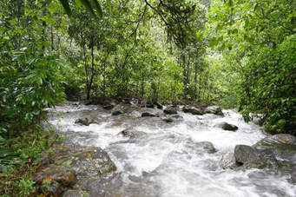

**Mysore ooty 3 Night 4 Days**

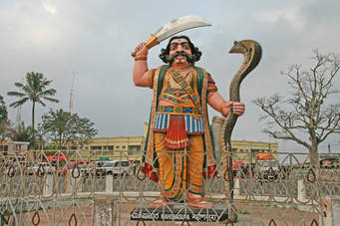

Sedan, Ac : 11700/

Innova,Ac : 18600/

Crysta,Ac : 19800/

Tempo travellar : 19300/

Tempo travellar A/c : 21700/

Tavera : 17400/

**Sight seen**

**mysore**

Tippu summer palace, Gumbaz, Ranganatha tempele, Chamundi hills, Nandi statue, Zoo,

Mysore palace, Jagan mohan palace, Church, Old st,marry church, , Brundavan garden.

**ooty**

pykara falls, shooting spot, boat house, botanical garden, rose garden, dodda betta, tea factory,

coonoor dolphin nose, lamb rock, sims park,

**Mysore ooty and kodaikanal 5 Night 6 Days**

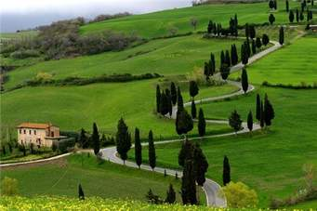

Sedan, Ac : 17200/

Innova,Ac : 27200/

Crysta,Ac : 29200/

Tempo travellar : 28500/

Tempo travellar A/c : 32000/

Tavera : 26300/

**Sight seen**

**mysore**

Tippu summer palace, Gumbaz, Ranganatha tempele, Chamundi hills, Nandi statue, Zoo,

Mysore palace, Jagan mohan palace, Church, Old st,marry church, , Brundavan garden.

**ooty**

pykara falls, shooting spot, boat house, botanical garden, rose garden, dodda betta, tea factory,

coonoor dolphin nose, lamb rock, sims park,

**kodaikanal**

kodaikanal lake, kurinji andavar temple, briyant park, cocker walk, silver cascade falls, pillar rocks, green valley.

**Mysore , Waynad** **3 Night 4 Days package**

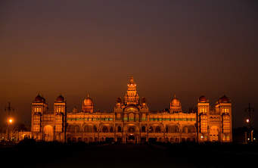

Sedan, Ac : 12100/

Innova,Ac : 20500/

Crysta,Ac : 23100/

Tempo travellar : 23750/

Tempo travellar A/c : 26350/

Tavera : 20500/

**Sight seen**

**mysore**

Tippu summer palace, Gumbaz, Ranganatha tempele, Chamundi hills, Nandi statue, Zoo,

Mysore palace, Jagan mohan palace, Church, Old st,marry church, , Brundavan garden.

**waynad**

kuruva island, chembra peak, edakkal cave, muthanga wildlife senctury, pazhassi raja tomb, lakkidi, soochippara water falls,

**Munnar and Allephy 4 night 5days package**

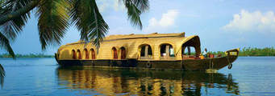

Sedan, Ac : 17800/

Innova,Ac : 26500/

Crysta,Ac : 29500/

Tempo travellar : 30500/

Tempo travellar A/c : 33400/

Tavera : 26400/

**Sight seen**

**Munnar**

Devikulam, mettupetty dam, anamudi, pothemadu point, hydel park, munnar tea museam.

**Allephy**

Marari beach, boat one night stay

**Goa 2 night 3 days package**

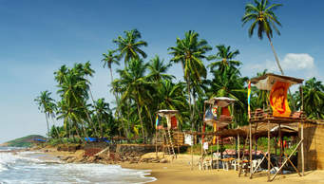

Sedan, Ac : 13400/

Innova,Ac : 20900/

Crysta,Ac : 22200/

Tempo travellar : 23900/

Tempo travellar A/c : 26500/

Tavera : 19600/

**Sight seen**

**Pondycherry 1 night 2 days package**

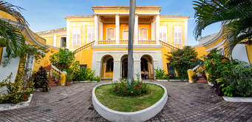

Sedan, Ac : 8850/

Innova,Ac : 12850/

Crysta,Ac : 14250/

Tempo travellar : 14450/

Tempo travellar A/c : 15950/

Tavera : 12650/

**Sight seen**

Bessilica heart church, botanical garden, paradise beach, Gandhi statue, arbindo ashram, museam, aralimugu manukula vinayagar temple, boat house,auroville.

**Shirdi 2 night 3 days package**

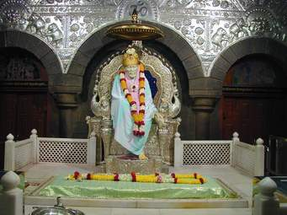

Sedan, Ac : 22900/

Innova,Ac : 33400/

Crysta,Ac : 35500/

Tempo travellar : 36800/

Tempo travellar A/c : 41000/

Tavera : 29400/

**Sight seen**

Hampi, badaami, ihole, pattadakallu, koodala sangama, allamatti dam, bijapur gumbaz, pandarapura, shiradi.

**One day Nandhi hills**

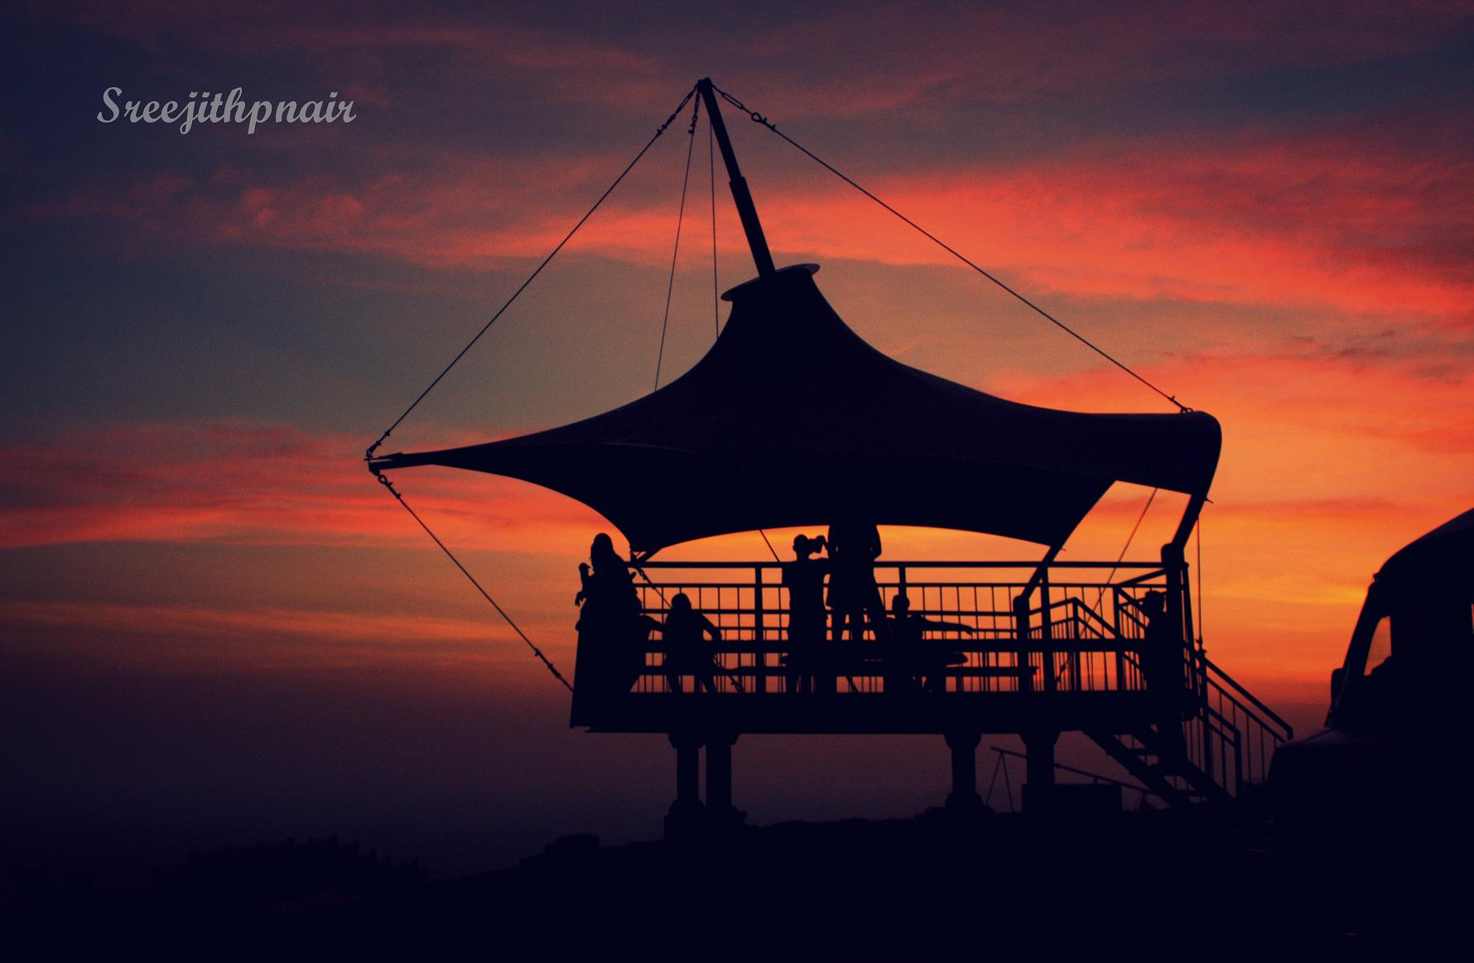

Sedan, Ac : 2600/

Innova,Ac : 3650/

Crysta,Ac : 4100/

Tempo travellar : 3700/

Tempo travellar A/c : 4150/

Tavera : 3400/